Marymede Catholic College
Individual Anaphylaxis Management Plan
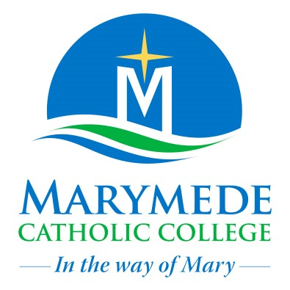

Marymede Catholic College is a multi-campus school which operates with the consent of the Catholic Archbishop of Melbourne and is owned, operated and governed by Melbourne Archdiocese Catholic Schools Ltd (MACS).
This plan is to be completed by the principal or delegate based on the information provided by the student’s medical practitioner as per the ASCIA Action Plan for Anaphylaxis provided by the parent/guardian/carer.
It is the responsibility of the parent/guardian/carer to:
- provide the school with a copy of the student’s ASCIA Action Plan for Anaphylaxis containing the emergency response plan (signed by the medical practitioner) and any medication or autoinjector referenced in the plan.
- provide an up-to-date photo of the student (to be appended to this plan)
- inform the school if the child’s medical condition, insofar as it relates to relates to allergy and the potential for anaphylactic reaction, and if relevant provide an updated ASCIA Action Plan.

School: |  | Telephone:
Student:
Date of birth: |  | Year level:
Severely allergic to:
Other health conditions:
Medication at school:
Other medication administered at home:

Emergency contact details (Parent/guardian/carer)
Contact 1
Name:
Relationship:
Contact numbers |  | List preferred order for contact
Home telephone:
Work telephone:
Mobile:
Address:
Contact 2
Name:
Relationship:
Contact numbers |  | List preferred order for contact
Home telephone:
Work telephone:
Mobile:
Address:

Emergency Contact Details (Alternative)
Alternative contact 1
Name:
Relationship:
Home telephone:
Work telephone:
Mobile:
Address:
Alternative contact 2
Name:
Relationship:
Home telephone:
Work telephone:
Mobile:
Address:
Essential Medical Information
Medical practitioner name: |  | Phone:
Emergency care to be provided at school:
Storage location for autoinjector device:
Date of expiry of autoinjector:

Environment
To be completed by the principal or delegate. Please consider each environment/area (on or off school site) the student will be in for the year, e.g., classrooms, school yards, specialist teaching areas, excursions, camps.
Name of environment/area:
Risk Identified | Actions required to minimise the risk | Who is responsible | Completion date?

Name of environment/area:
Risk Identified | Actions required to minimise the risk | Who is responsible | Completion date?

Name of environment/area:
Risk Identified | Actions required to minimise the risk | Who is responsible | Completion date?

Name of environment/area:
Risk Identified | Actions required to minimise the risk | Who is responsible | Completion date?

Name of environment/area:
Risk Identified | Actions required to minimise the risk | Who is responsible | Completion date?

Approval authority | Director, Learning and Regional Services
Approval date | 5 July 2023
Next review | March 2025
Publication details | Marymede Catholic College website

