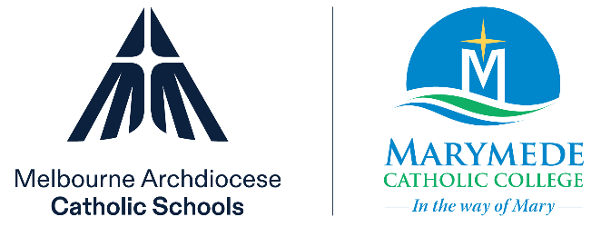

Position Description
Learning Support Officer
South Morang

Purpose of position | To provide additional support to students with identified needs
Staff Team | Learning Diversity
Reporting to | Director of Learning Diversity
Location | Marymede Catholic College:  - 60 Williamsons Road, South Morang  - 139 Eminence Blvd, Doreen
Classification | Education Support Officer Level 2, Category B
Salary and benefits | - Salary range: $56,579 - $72,459 pro rata
Commencement date | To be confirmed
Employment conditions | - 5 days per week and Ongoing  - All school holidays  - Working hours are 8.45am to 3.15pm, Monday to Friday (30-minute lunch break)  The successful applicant will:  - be subject to a satisfactory National Police Record Check and Employee Working with Children Check  Visa sponsorship is not available for this position. All applicants require current and valid working rights for Australia.
Qualifications and experience | - Certificate IV in Educational Support  Marymede Catholic College is an equal opportunity employer. We value a diverse and inclusive workplace and welcome applications from all qualified people. When required, we make reasonable adjustments to accommodate our people.

Key duties and responsibilities
Role Responsibilities
- The role responsibilities draw upon the Catholic Education Multi-Employer Agreement (2022). The role revolves around a demonstrated commitment to professional knowledge, professional practice and professional engagement.
- To support funded integration students and assist their integration into mainstream classes.
- To assist with specific needs of students - toileting, scribing, extra discussion of concepts, assistance with computer, reading questions, note taking, etc.
- Modification of student work, preparation of revision sheets, modification of exams/tests.
- To perform clerical tasks such as photocopying associated with modification of materials for Integration students.
- To work in collaboration with class teachers.
- To work closely with special education teachers and any consultants or therapists who work with the integration students.
- To provide pastoral support for students.
- Parent liaison - to attend integration support group meetings and informal discussions with parents.
- To assist with record keeping and documentation associated with integration students.
- To assist, where appropriate, with transition planning for students moving out of secondary education.
- To attend Domain meetings.
- To attend excursions and camps.
- To attend whole school meetings when required.
- To attend the annual College Open Day.
- To fulfill the professional requirements of punctuality, professional attire and professional communication standards.
Health & Safety
All staff are expected to:
- Adhere to and implement safe work practices and procedures in accordance with Marymede Catholic College policies.
- Work safely and report any hazards in accordance with College procedures.
- Monitor and take full care of the health and safety of others.
- Participate when required in the resolution of safety issues.
Other Specific Duties
- As required by the Principal and as outlined in the Certified Agreement CEMEA 2022.

Key selection criteria
- Possess the skills, experience and qualifications to perform the duties and responsibilities of the position
- Ability to work collaboratively within a team
- Excellent interpersonal and communication skills
- Ability to handle sensitive and confidential information appropriately
- Ability to plan effectively and multitask
- Commitment to supporting the Catholic Identity of the College
- Commitment to and understanding of child protection and child safety issues in schools
- Commitment to safe work practices
- Commitment to professional learning and development
- Commitment to the implementation of College policies and procedures

Child Safety Requirements
Marymede Catholic College is committed to developing a culture to maintain the safety of each student in our care. At Marymede Catholic College we have a zero tolerance for child abuse and are committed to acting in children’s best interests and keeping them safe from harm.
The College regards its child protection responsibilities with the utmost importance and as such, is committed to providing the necessary resources to ensure compliance with all relevant child protection laws and regulations and maintain a child safe culture. All staff employed at Marymede Catholic College are required to abide by our Child Safe Policies and commit to our Child Safe Code of Conduct.

Position description updated: | November 2025

